Electronic pressure switch
with flush diaphragm

Klingenberg, February 2012
For industrial processes with "critical" media, WIKA has expanded its range of electronic pressure switches with a new model: the PSD-31 with flush diaphragm.

The instrument is particularly suited for application in abrasive, aggressive, adhesive, crystalline and viscous media. Its flush connection eliminates any clogging of the pressure channel with particles and also prevents possible contamination of the process.
Technically, the new pressure switch is the same as the highly-functional and award-winning PSD-30. Due to its small size and the ability to rotate both the display and connection, it is particularly flexible for mounting. Its simple menu structure (in accordance with the VDMA standard) enables quick and easy operation, while a large LED display provides excellent readability. The switch is available in several country-specific versions, for use worldwide. Its quality and safety are documented by its cULus listing.

Further information can be found at:
www.wika.de/psd-31
www.pressuresensor-knowhow.com

Number of characters: 1095
Key word: PSD-31

Manufacturer:
WIKA Alexander Wiegand SE & Co. KG
Alexander-Wiegand-Straße 30
63911 Klingenberg/Germany
Tel. (+49) 9372 132-0
Fax (+49) 9372 132-406
E-mail sales@wika.de
www.wika.de

WIKA company photograph:
Electronic pressure switch PSD-31

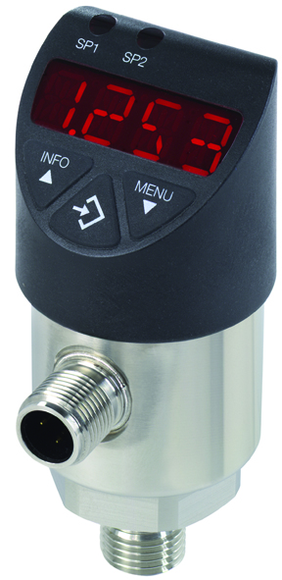

Edited by:
WIKA Alexander Wiegand SE & Co. KG
André Habel Nunes
Marketing Services
Alexander-Wiegand-Straße 30
63911 Klingenberg/Germany
Tel. (+49) 9372 132-8010
Fax (+49) 9372 132-8008010
E-mail a.habel-nunes@wika.de
www.wika.de/psd-31

WIKA press release 03/2012

