New temperature sensors
in miniature design

Klingenberg, January 2014.
They are so small that you hardly notice them: With their minimal design, the new temperature sensors from WIKA fit in even the tightest of spaces. The model TF40 was developed specifically for use in ventilation ducts; the model TF41 for the measurement of outside temperatures.

The measuring elements of both sensors are inserted into a UV-resistant plastic housing that measures just 44(l) x 32(w) x 30(h) mm. The new instrument, classified with IP 65 ingress protection, can be supplied with a choice of Pt1000, Pt100, NTC or a customer-specific solution. Thus they are compatible with all the common control systems.

The model TF40 is tailored to the needs of air-conditioning and ventilation technology. Optional equipment includes a plastic mounting flange and a thermowell. The model TF41 is primarily suitable for the fields of renewable energies, HVAC and refrigeration technology. For this model, there is an additional, clip-on protective module to prevent erroneous measurements as a result of too strong incident sunlight in outside applications.

Number of characters: 1127
Key words: TF40/TF41

Manufacturer:
WIKA Alexander Wiegand SE & Co. KG
Alexander-Wiegand-Straße 30
63911 Klingenberg/Germany
Tel. +49 9372 132-0
Fax: +49 9372 132-406
vertrieb@wika.com
www.wika.com

WIKA company photograph:
WIKA temperature sensors TF40 and TF41

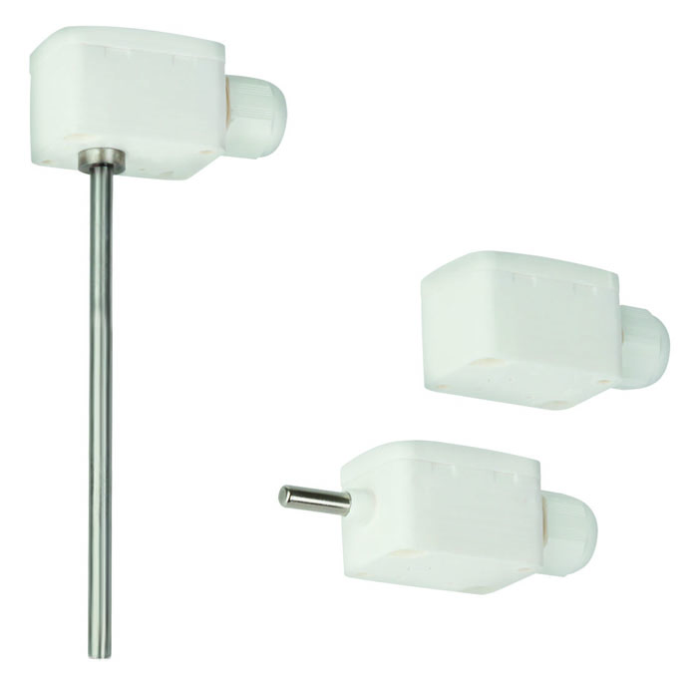

Edited by:
WIKA Alexander Wiegand SE & Co. KG
André Habel Nunes
Marketing Services
Alexander-Wiegand-Straße 30
63911 Klingenberg/Germany
Tel. +49 9372 132-8010
Fax: +49 9372 132-8008010
andre.habel-nunes@wika.com
www.wika.com

WIKA press release 01/2014

