New Euromisure website is now online

Cremona, January 2014.
Fresh design, efficient navigation and new functionalities: on the new website visitors can now get information with fewer clicks.

In 2012, the WIKA group acquired Euromisure to complete its product portfolio of mechanical components for the process industry and EPC contractors globally. Now, a further step in the integration of the company has been done: a new web appearance.

The new website is much tidier, visually clearer and with a wider range of services to offer. Customers can, for example, find the instrument they are looking for directly via mega menus. By using the contact boxes on the same level, the appropriate sales contacts for each country can be identified.

The new Euromisure’s website also let you know the news and the fairs or events in the WIKA Group and you can download dedicated questionnaires in an editable PDF format to be used for your request of quotations. On top of this, it’s now also optimised for search engines and tablet PCs.

Number of characters: 1.025
Key words: New Euromisure’s website

Manufacturer:
Euromisure Sas di WIKA Italia Srl
Via Borghisani 4
Pieve San Giacomo
26035 - Cremona
Italy
Tel.:+39 (0372) 6404411
Fax:+39 (0372) 640490
euromisure@euromisure.it
www.euromisure.it

Euromisure company photograph:
New Euromisure website

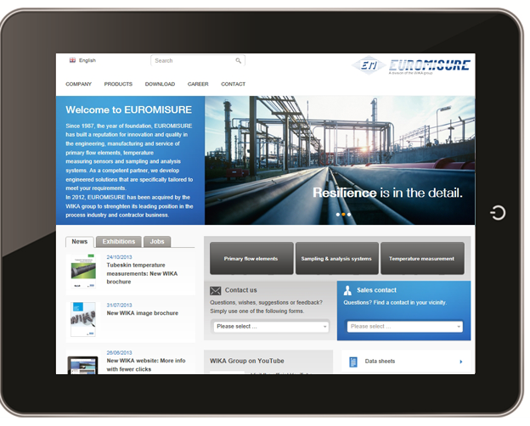

Edited by:
WIKA Italia Srl & C. Sas
Massimo Beatrice
Marketing Specialist
Via Marconi, 8
20020 Arese (MI)
Tel +39 • 02 • 9386151
Fax +39 • 02 • 9386174
E-Mail massimo.beatrice@wika.com
Internet www.wika.it

Euromisure press release 01/2014

